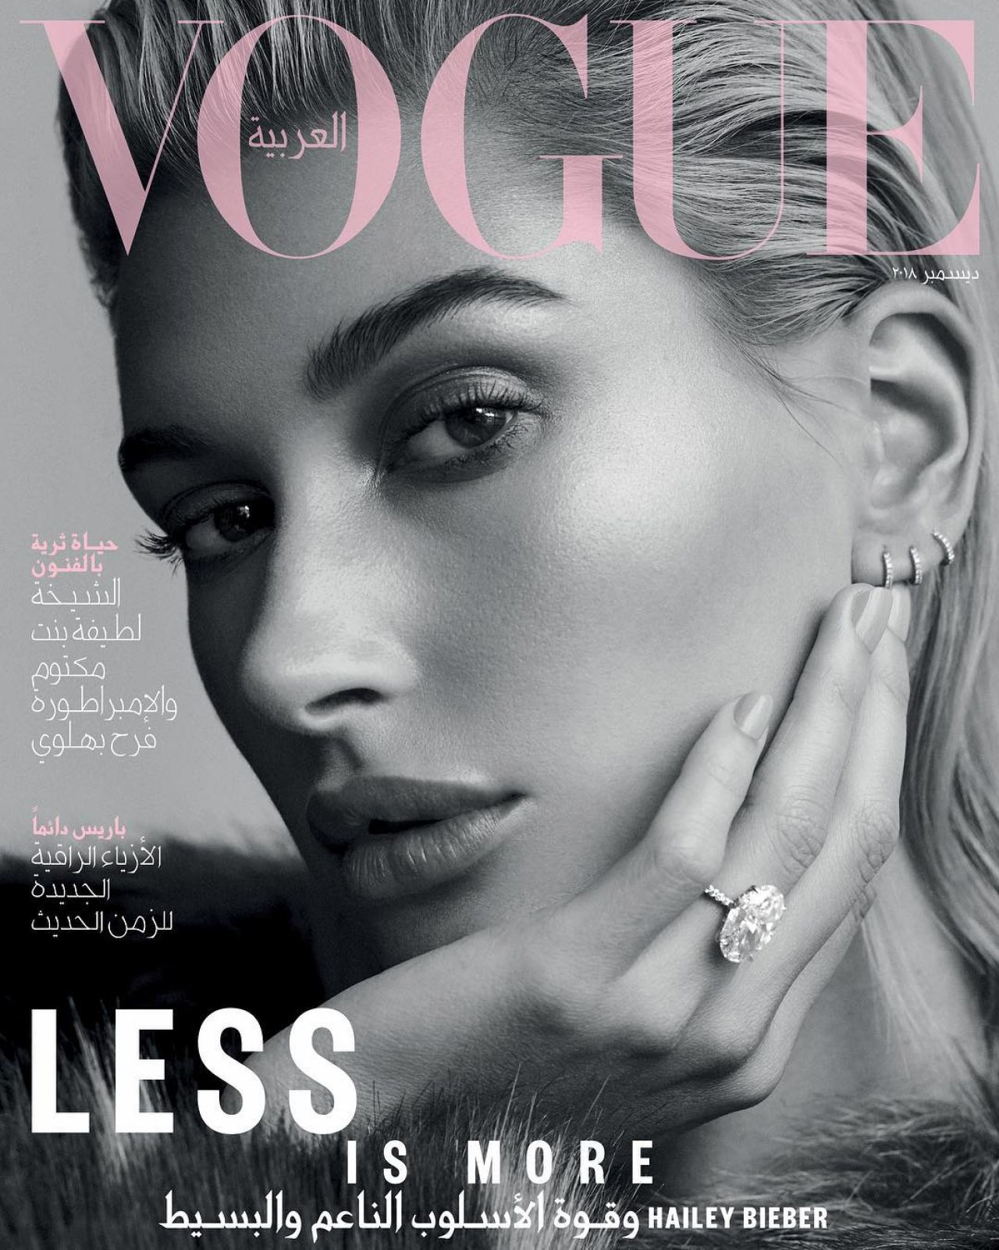
Throughout my process of creating my magazine I have made sure it has conformed to the codes and conventions of a fashion magazine. My magazine promotes high street fashion which is affordable for my target audience which is females ages 16-23. I have chosen this genre of magazine as I believed that I was best suited for this and could put my all into it. I took inspiration from a variety of magazine when creating mine, such as when creating my front cover I took inspiration from ‘Vogue’, and not in the sense that the way in which they promoted the fashion, but the way in which they laid out their double page spreads and front covers and how they appeared to the audience. Before starting to produce my magazine I went through the pre-production stages where I planned my magazine. I believe that this planning stage ensured the production of my magazine to run smoothly. If I had not completed this planning stage, I believe that the process may not have gone this smoothly. A main feature that I was inspired by when I began thinking about my masthead was the transparency in the text. I saw this on one of the Vogue front covers and instantly knew that this was what I wanted on my front cover. As well as using this feature on my front cover, I have carried it over to both my double page spreads and I have done this because it allows my readers to have a sense of familiarity when reading my magazine and it gives my magazine a whole sophisticated and professional look and feel when reading through. By having a look at existing magazines, it allowed me to have a deeper look into the industry which then allowed me in the future to produce my final piece. The actual name of my magazine, ‘Apparel’ means clothing and fits in perfectly with my fashion magazine. However, while choosing my masthead, I was between two names, ‘Aurora’ and ‘Apparel’, after asking for feedback on my name options, I soon realised that ‘Apparel’ was best suited.
I used a full bleed image of a young female model who is a similar age to my target audience therefore meaning they would be able to relate and identify with her, especially females who are into fashion and can take advice from her which is effective as they would feel as if they are benefiting by reading and purchasing the magazine. My image includes my model's body up to her knees which focuses on her outfit. I decided to place a silhouette in front of the camera and the model as I believed that this was a unique idea and instantly made my magazine stand out. My model is dressed in minimalistic attire of leather trousers with a long sleeve top and a fur coat, with simple makeup, emphasising the outfit which is also supported by her facial expression and body language. She is also dressed and follows the stereotypes of what young people would traditionally wear therefore attracting them to purchase the magazine as they can identify and relate.
The sell lines on my front cover all have a meaning behind and in some sort of way link in with either the image on the front cover or the articles featured inside the magazine. My main sell line ‘The woman in you’ is placed at the bottom of my front cover, in the largest text size, in order to catch the audience's attention. The meaning behind that sell line is that the woman (my model) is inside the silhouette. When writing my sell lines I wanted to keep them short and give out enough information to intrigue the potential readers to buy the magazine but not too much information to the point where there's no point buying and reading the magazine.
Below my masthead I included my website and above my masthead you can see the date and price of my magazine. The price of my magazine is £3.99 which shows its high street fell of the actual magazine and the content inside it, in addition it is affordable. The reason why my magazine was priced at that was because my target audience is females aged 16-23, most may still be in education, therefore, not ensuring that they have a stable source of income and £3.99 being a reasonable price.
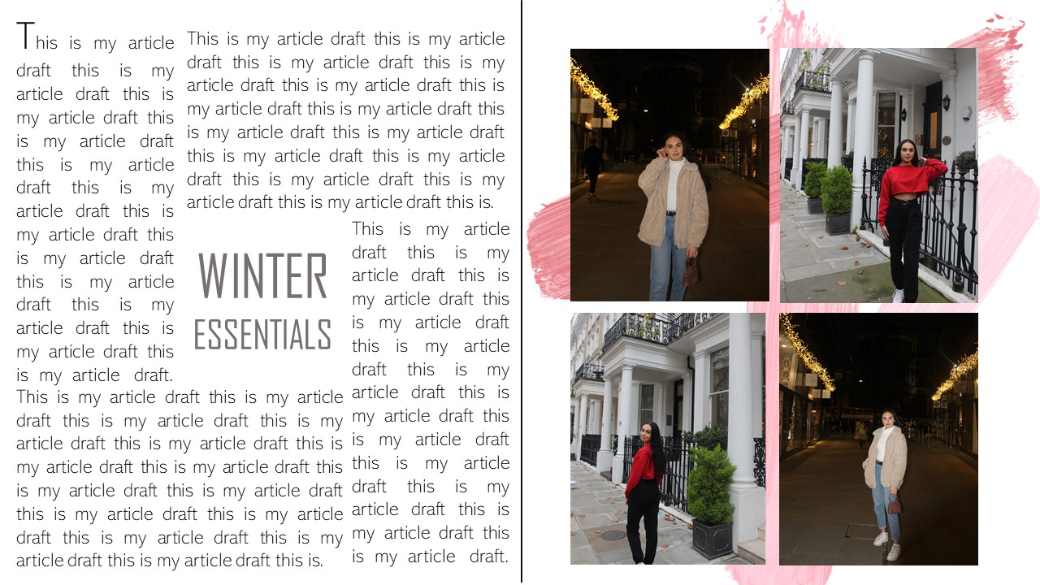
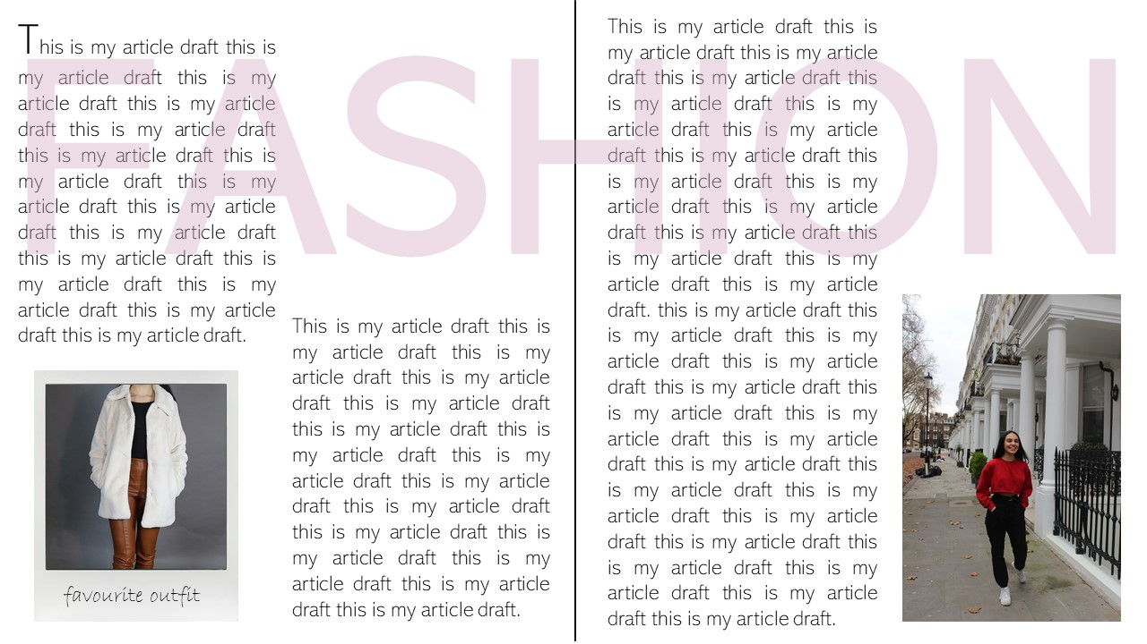
When producing my double page spreads, I showed my double page spreads to my targeted audience and I received feedback which was not as positive as I hoped, leading to me making significant changes to my double page spreads. After making those changes I showed them my new double page spreads and the feedback was far more positive. My drafts for my double page spreads looked like this:
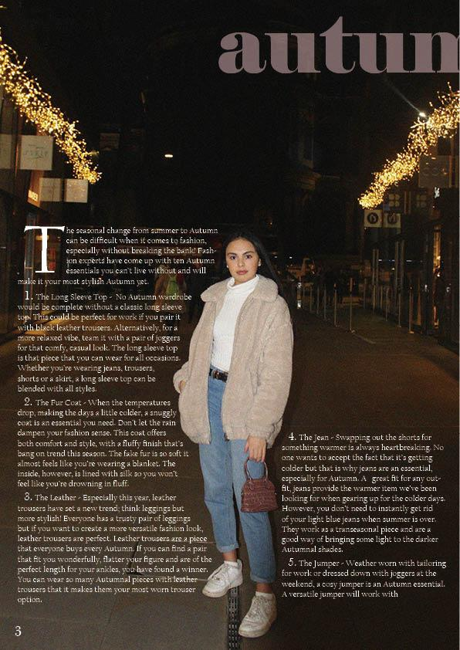
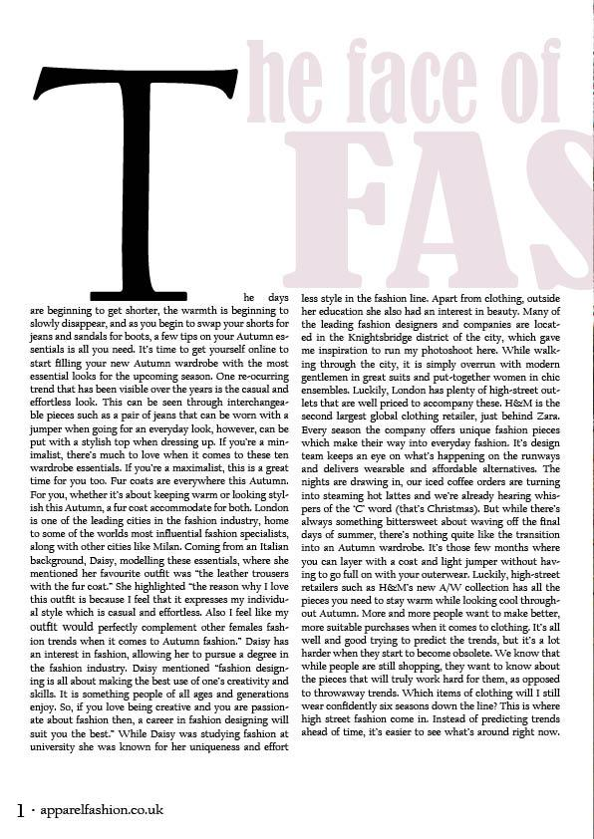
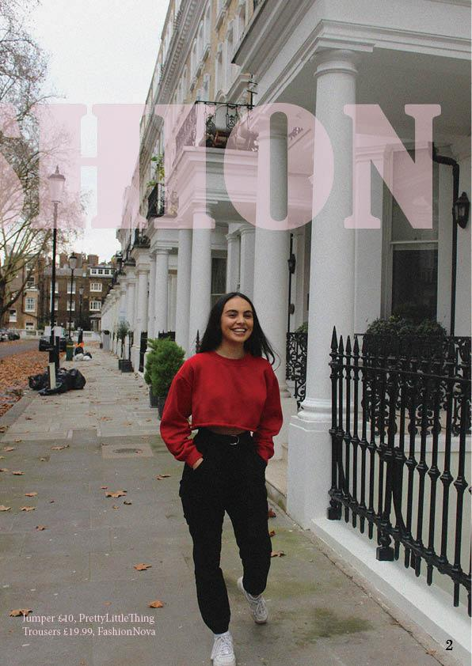
My final double page spreads now look like this:
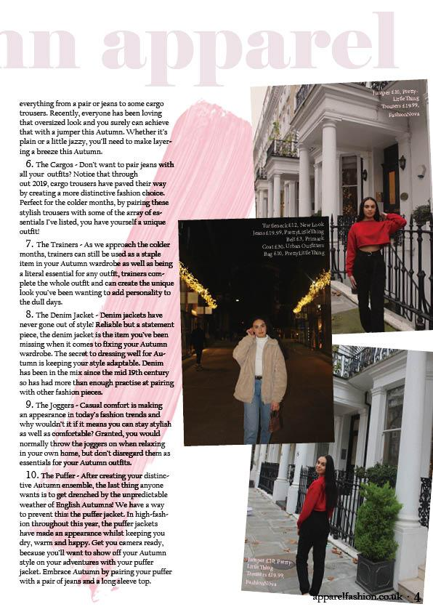

As you can see from my drafts and my final products there were a lot of changes that I made to my double page spreads, allowing me to produce the best magazine I could.
I represented a particular social group through my media product, mainly through the genre of my magazine, as well as the clothing my model was placed in. The demographic audience that I chose to target was C2D which includes the skilled working class and the working class. I chose this audience gap due to my target audience consisting of females ages 16-23 which is when we see most of them possibly still in education. When it comes to my psychographic audience, I decided to target reformers, main-streamers and explorers. My main fashion sector that I targeted was high street fashion which is stylish and affordable for my target audience, females aged 16-23. In addition to this, I represented my artist in an effortless style and placed her in casual clothing. Furthermore, her body language goes in hand with the style of clothing she will be wearing, casual and effortless.
Having the correct target audience and appealing your magazine to them is an extremely important aspect when it comes to the creation of a magazine. I firstly decide on the age range I would be aiming my magazine at as they would help me decide and conclude what to include in my magazine such as content, images, colours and the language used and whether it would relate and identify with that specific social group. I concluded that my primary audience would be fashion lovers who buy the magazine every month.
Furthermore, my fonts and colours used are effective in appealing to my audience and targeted social group. For example, I decided to use the colour pink as my main colour throughout my magazine as we see the colour pink associated with females, making my magazine appear stereotypical, which is what we see in the media a lot now.
I decided to use Condé Nast as my publishing house. Condé Nast is an American mass media company founded in 1909 by Condé Montrose Nast. I chose them as they manage some of the most famous magazine companies, such as Vogue and GQ. Additionally, the company’s media titles attract over 84 million consumers in print, 366 million in digital and around 384 million across social platforms.
There were a variety of ways I attracted my audience to my magazine, such as I made sure my design and layout was very simplistic but sophisticated to match the fashion I was promoting. I also used a variety of images with different backgrounds, some at a studio and some at locations, so my pictures differ from each other making my magazine more interesting to look through. I believe the front cover was a very important factor in being able to attract and address my audience as it is the very first thing the readers would see when walking into a shop, therefore, it would need to be well designed, making it eye catching. Therefore, this is one of the reasons why I decided to use the concept of the silhouette on my front cover as I had not seen it a lot before. My model is staring straight into the camera which is effective as she is making direct address therefore making it look as if the model is looking at potential readers as they pass by it in the store, influencing them to pick it up and purchase it.
Before creating my final fashion magazine I had previously used media softwares such as Adobe InDesign and Adobe Photoshop, as they are the softwares I has used in GCSE Media last year, therefore, I can say that I had a simple and foundation understanding of the software and how to use it in an effective way such as creating a layout or adding text, editing photos or removing backgrounds from images. However, I needed to add to my software knowledge and I did so by researching into these softwares and watching videos on how to complete specific tasks on both softwares. I created my whole magazine on Adobe InDesign, where I produced a layout of a mix of images and columns of text. Once I finished over the weeks I had been creating it, and all my text and final chosen images were placed in, I was left with a final finished professional looking product. Photoshop was an extremely helpful software which helped me enhance my magazine and make it look as realistic and professional as possible, as it allowed me to edit and improve my photographs I had taken of my model, while using specific tools such as adjusting colours, brightness, contrast and then adding noise onto my images. In relation to using InDesign I would say I have learnt new skills but also improved and advanced my ability on how to create a professional media product.
When it comes to the photo-shoot I used a Canon 550D camera to take the photographs, allowing my images to have the best and highest quality to make my images look more realistic and appealing to the audience's eye.
Looking back at when I first produced my magazine drafts to how I wanted my magazine to look, I believe I have improved massive amounts in terms of skills from the very first draft I produced.

